1. **Problem Statement: Socket Programming in C++**

**Design and implement a reliable and efficient network communication system using socket programming in C++ to enable data exchange between two or more processes running on different machines over a network.**

**Specific Requirements:**

**Socket creation: Create appropriate socket descriptors for the desired communication protocol (TCP, UDP, etc.).**

**Address binding: Bind the created socket to a specific network address and port number for both client and server applications.**

**Connection establishment: Implement connection setup mechanisms (connect, accept) for TCP-based communication.**

**Data transfer: Develop functions for sending and receiving data over the established socket connection.**

**Error handling: Incorporate robust error handling mechanisms to address potential network issues and unexpected exceptions.**

**Concurrency: For server-side applications, consider handling multiple client connections concurrently using appropriate techniques (e.g., threading, forking).**

**Security: Implement appropriate security measures to protect data integrity and confidentiality (e.g., encryption, authentication).**

**A: Server – Client**

**Server**

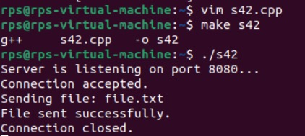

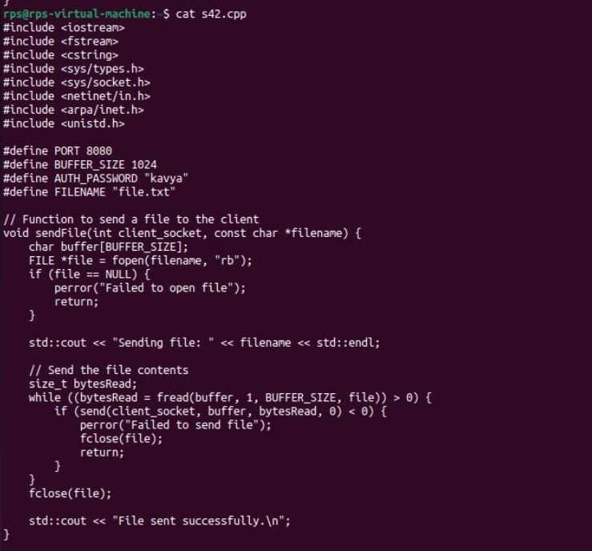

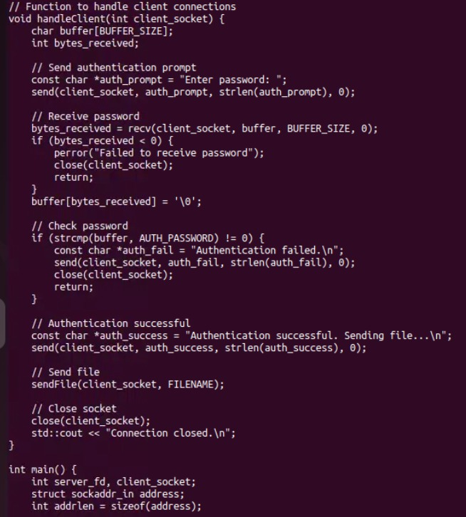

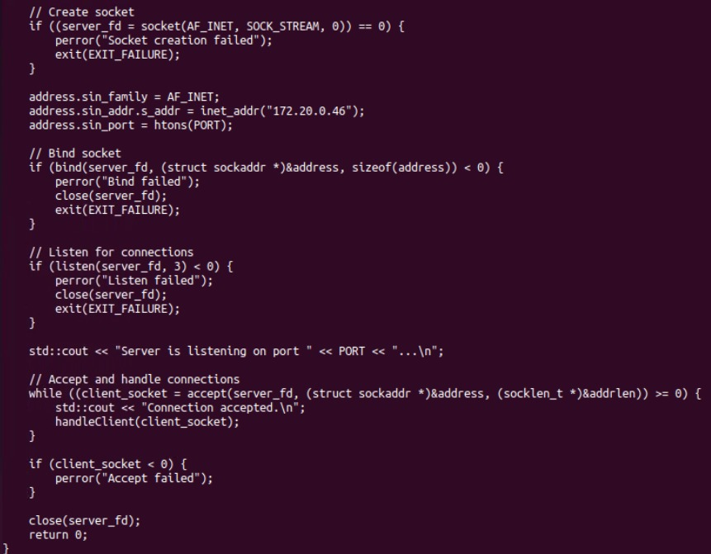

**Client**

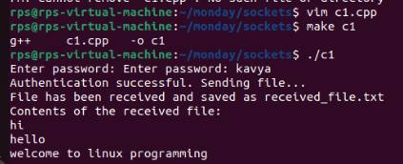

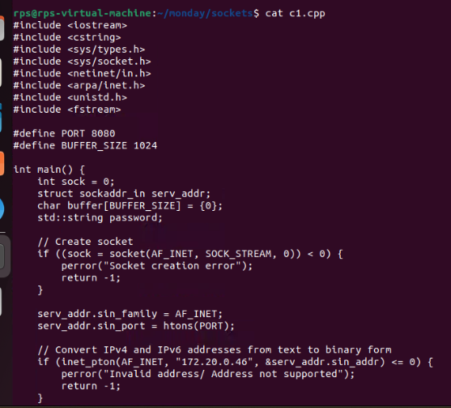

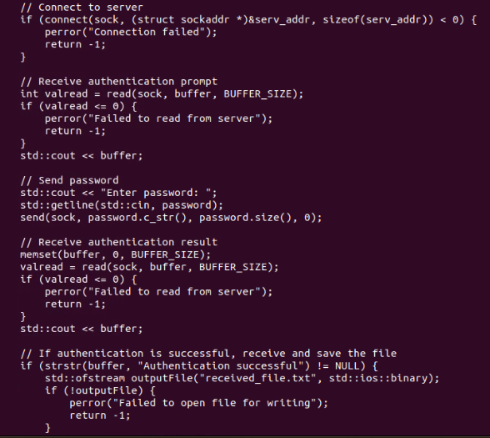

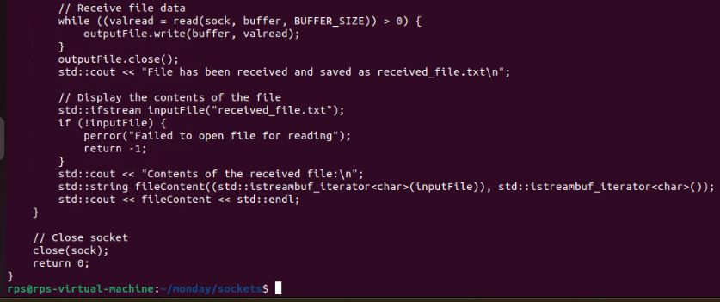

**Client – Server**

**Client**

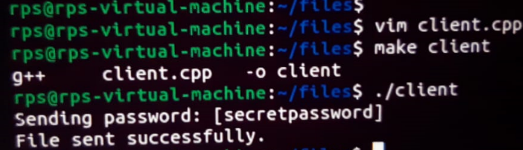

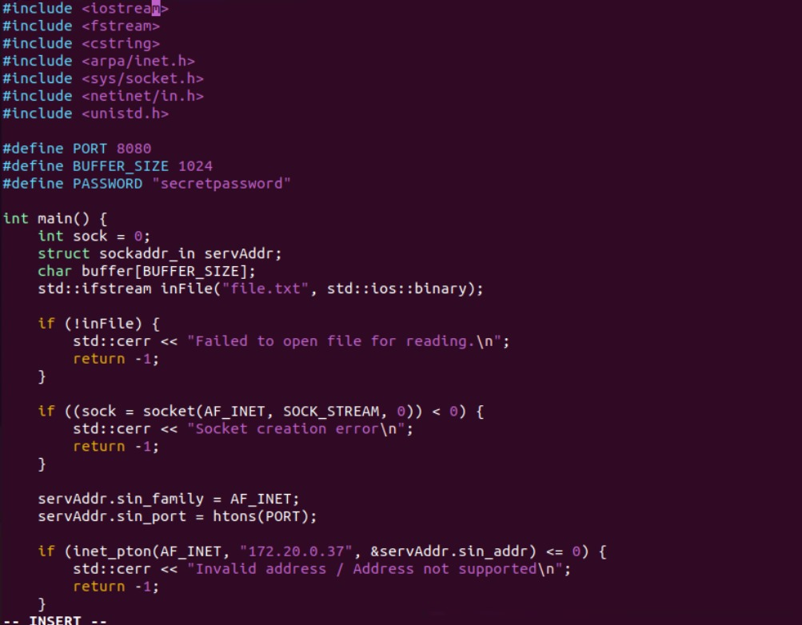

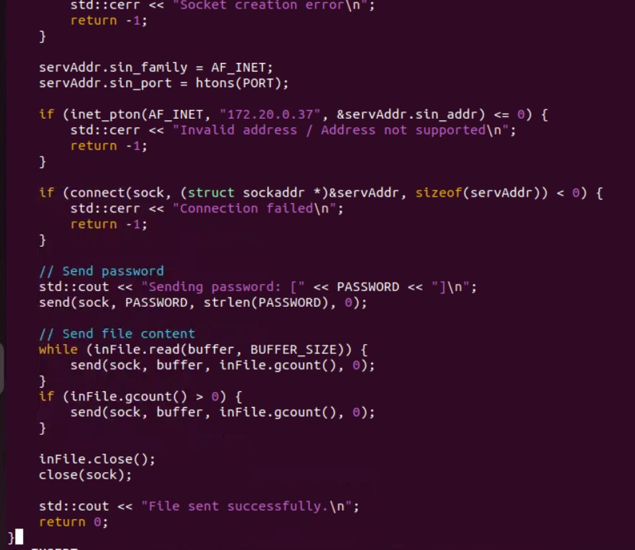

**Server**

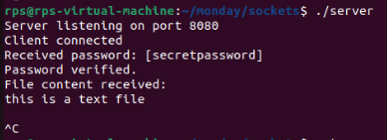

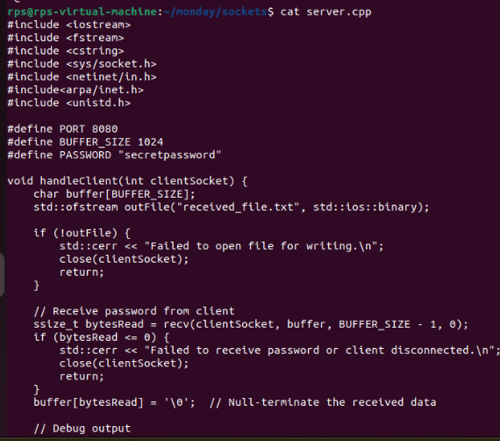

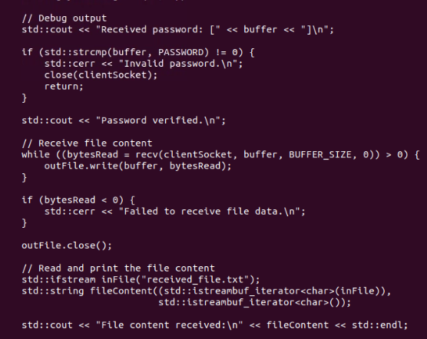

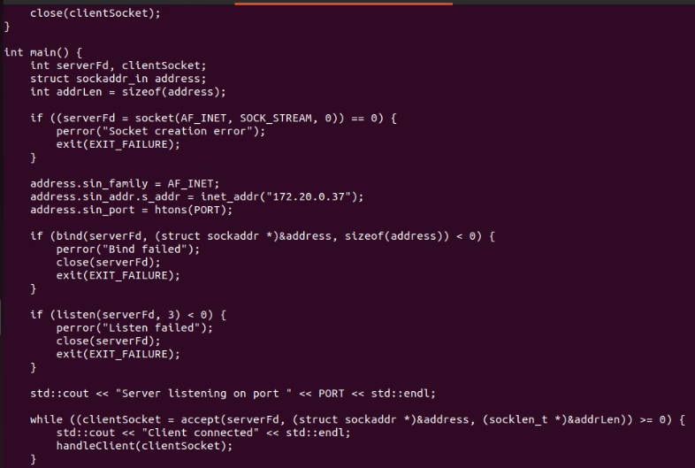

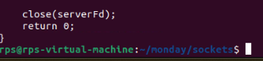

1. **IPC Using Sockets**

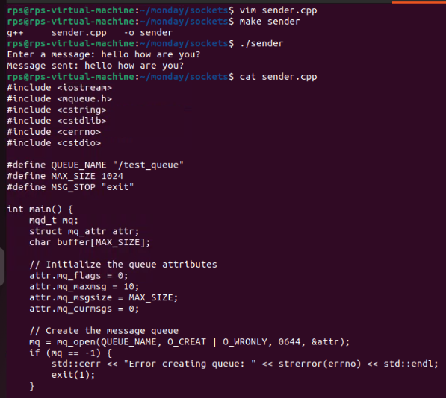

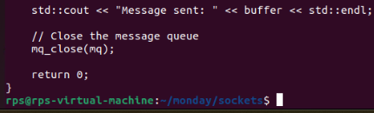

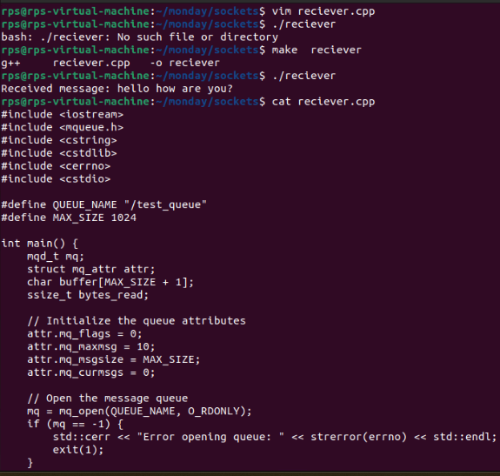

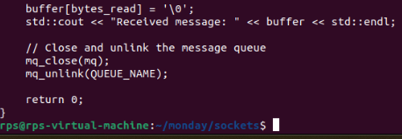

**3.Message queue:**

**Process 1:**

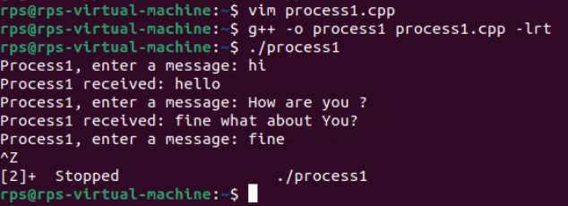

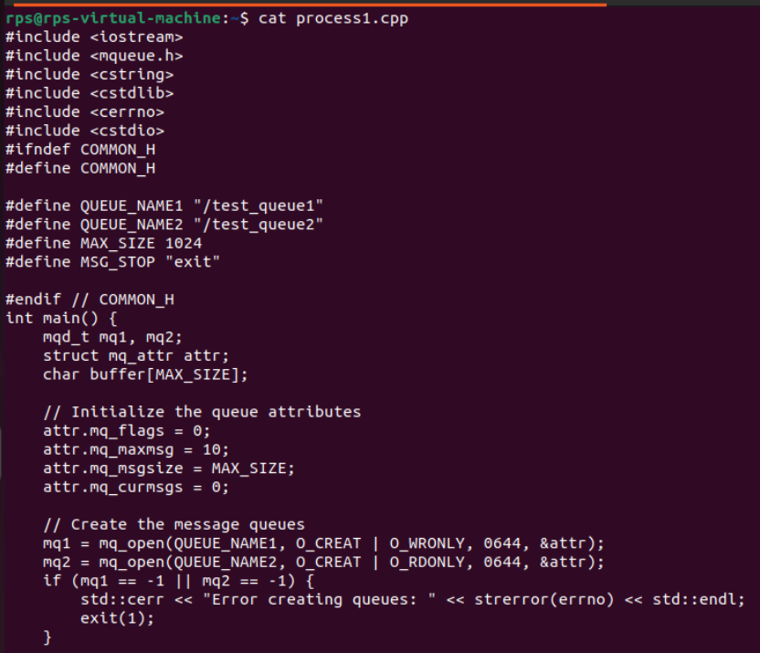

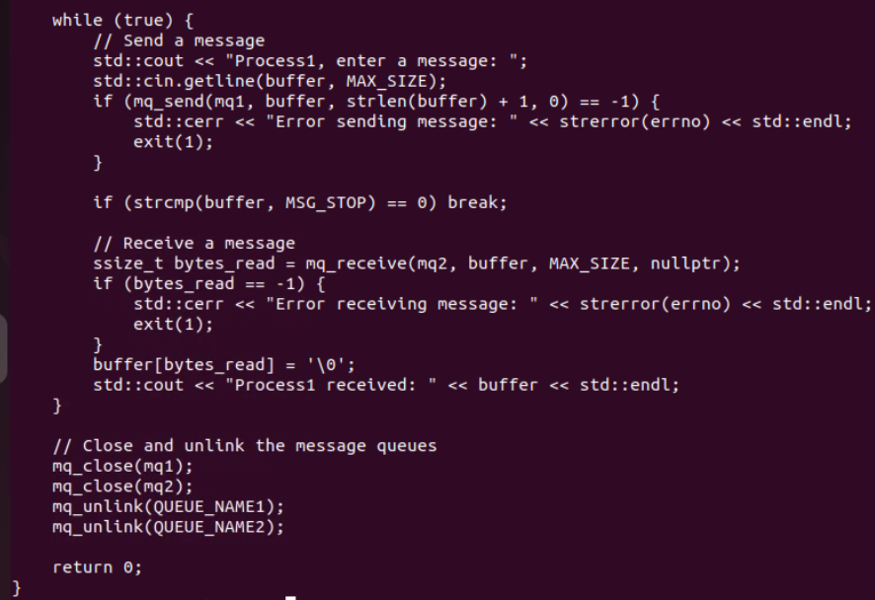

**Process 2:**

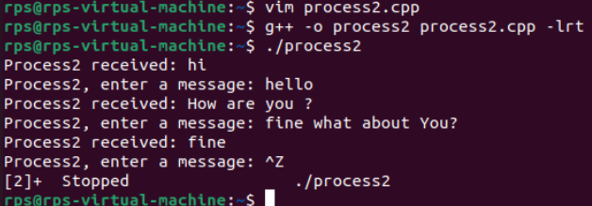

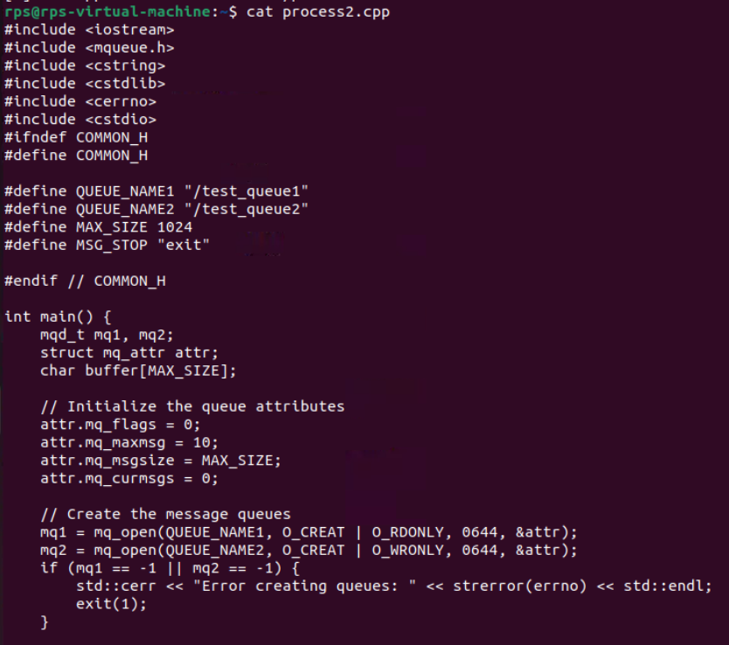

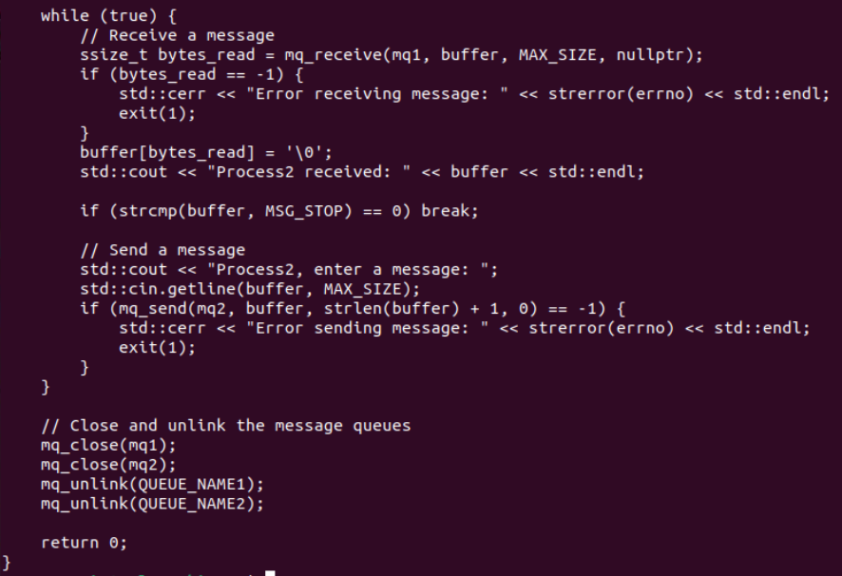

**4.Pthread**

**Process 1:**

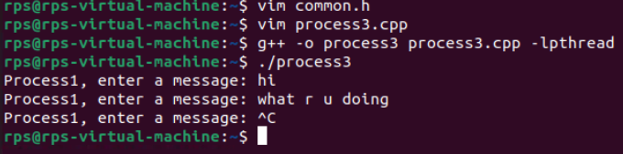

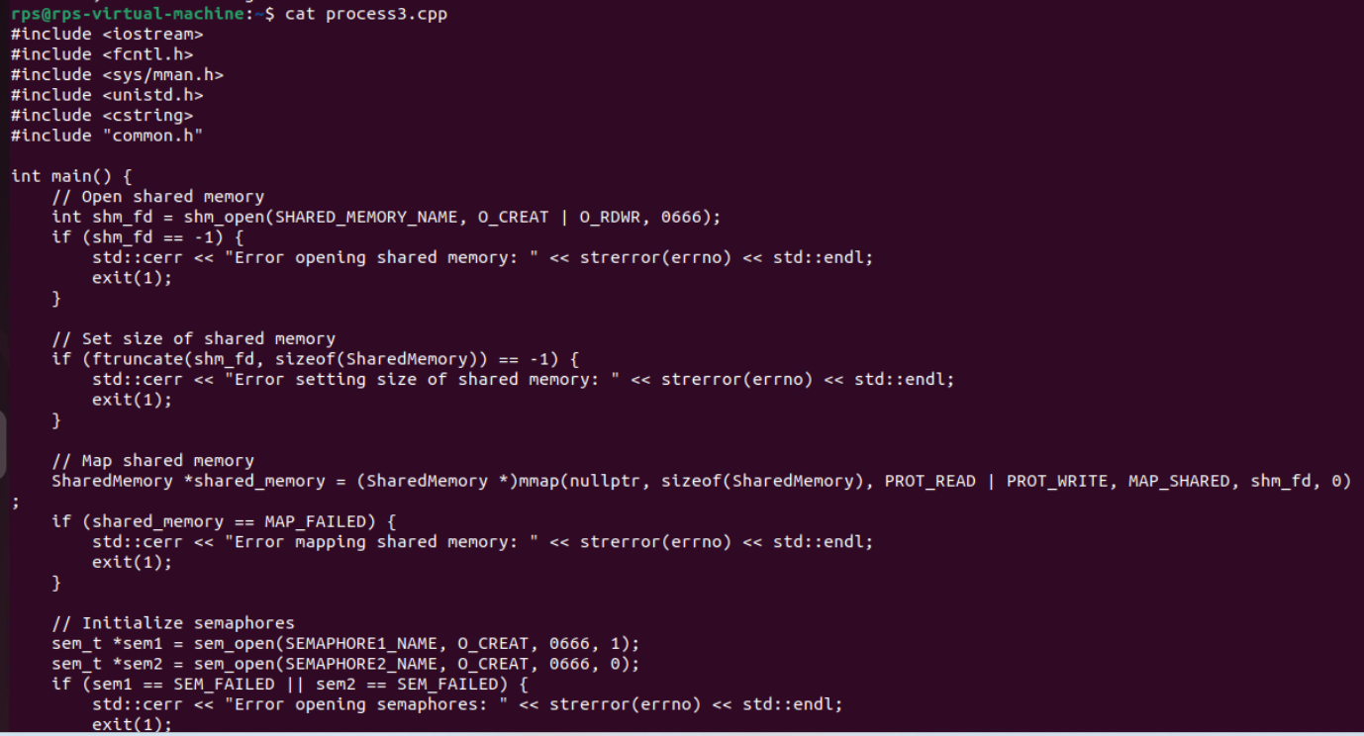

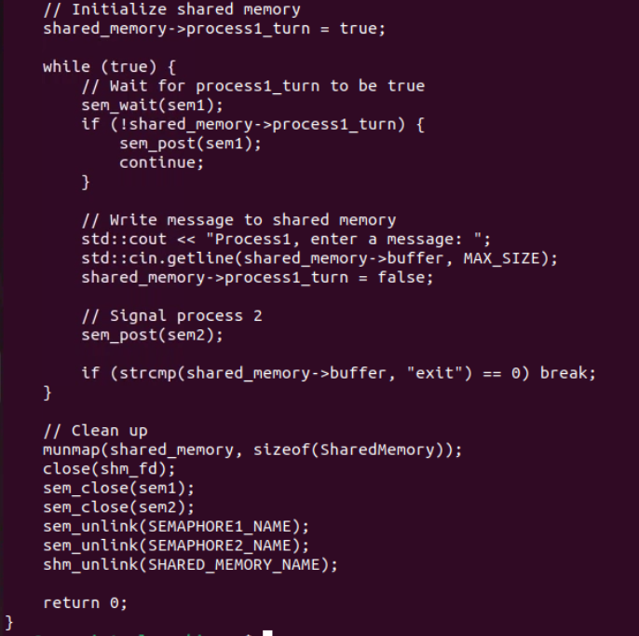

**Process 2:**

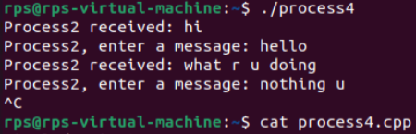

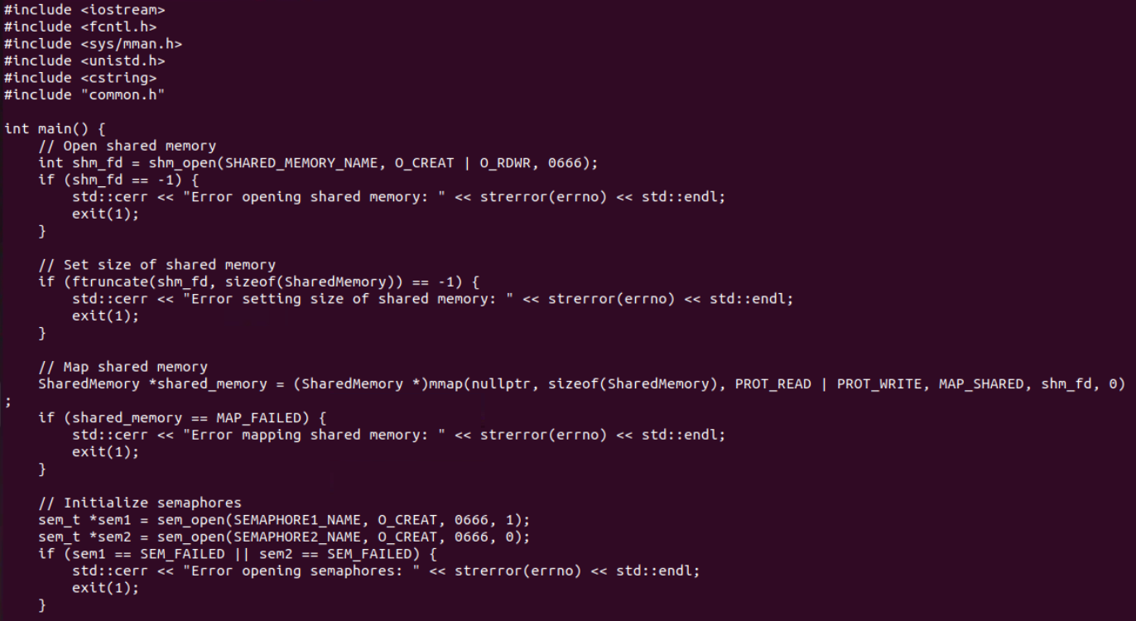

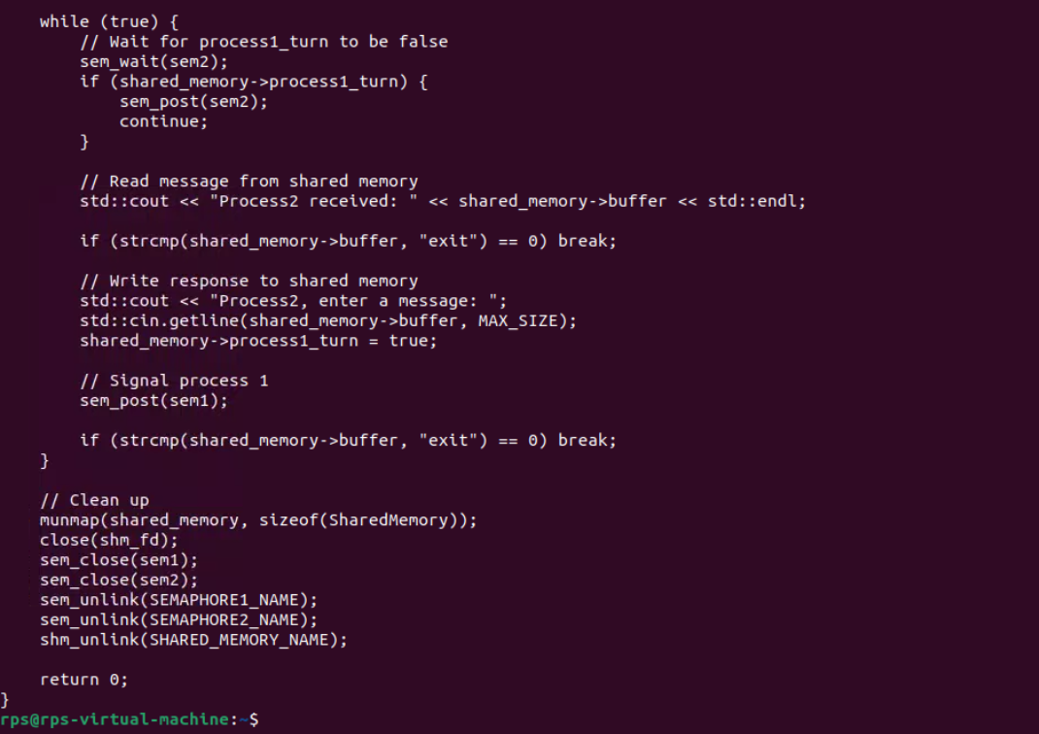

**Fork and Exec**

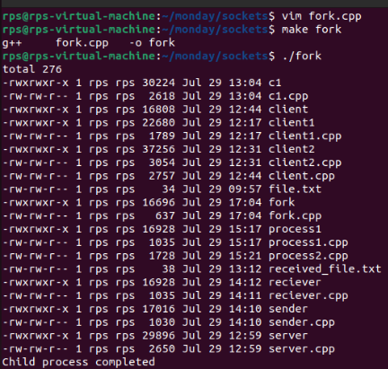

**Pipe:**

**Pipe 1:**

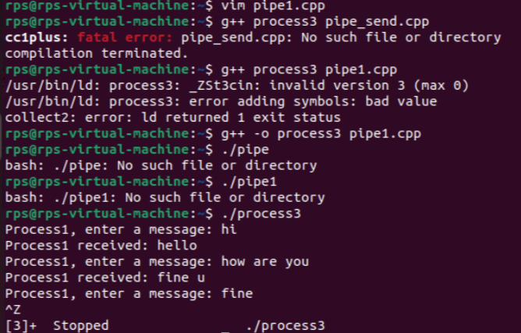

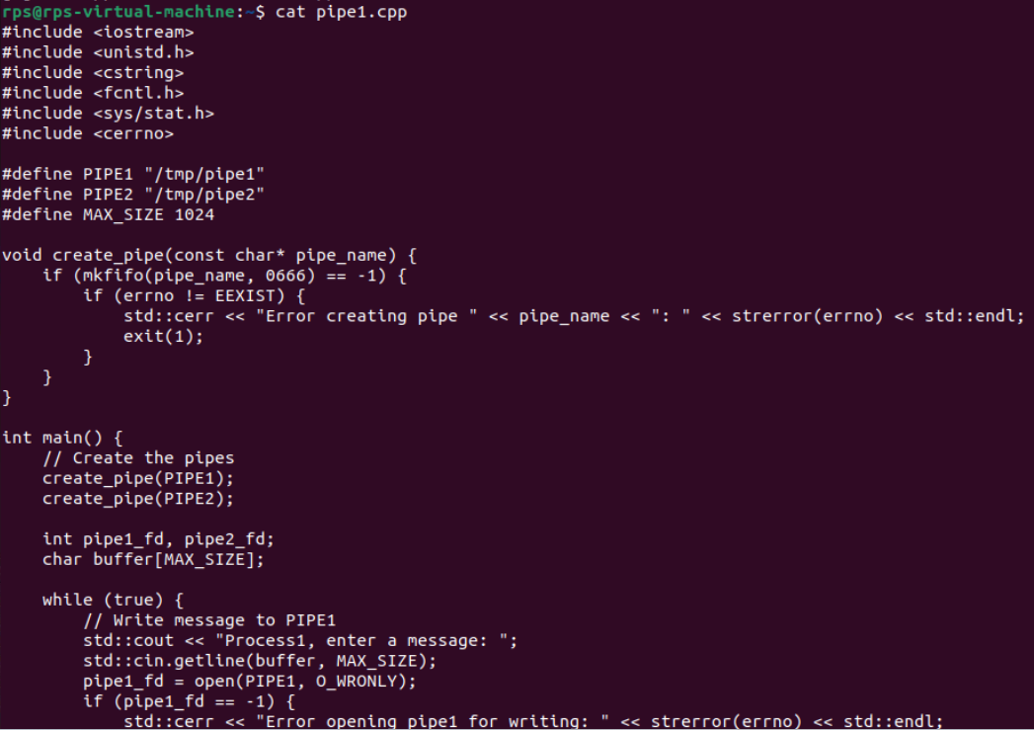

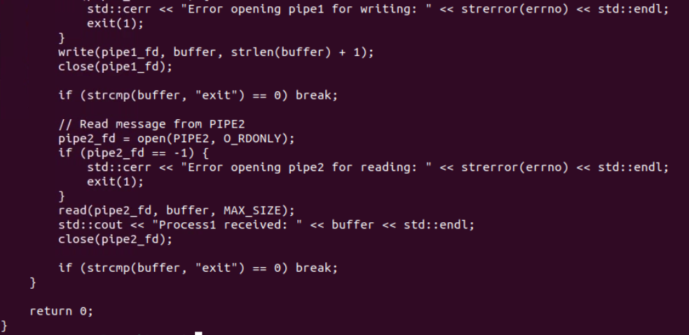

**Pipe 2:**

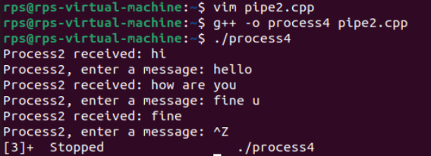

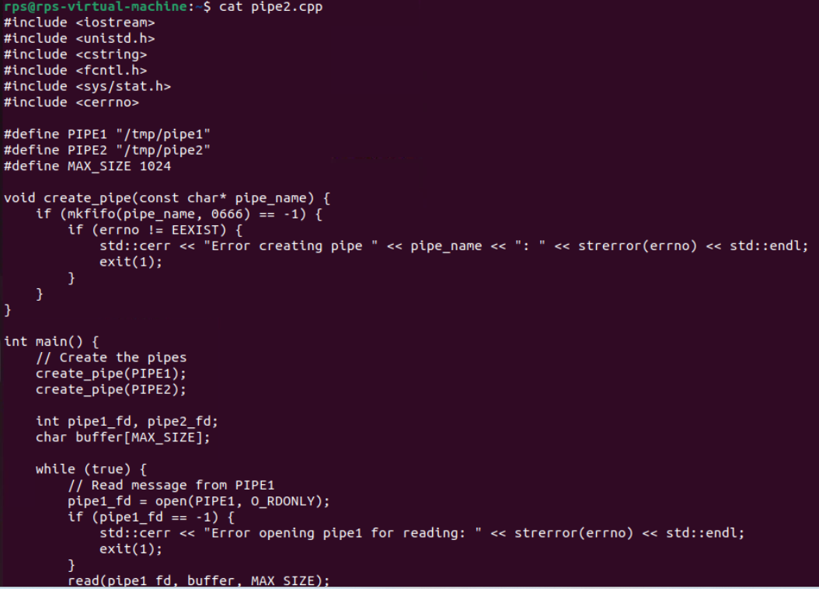

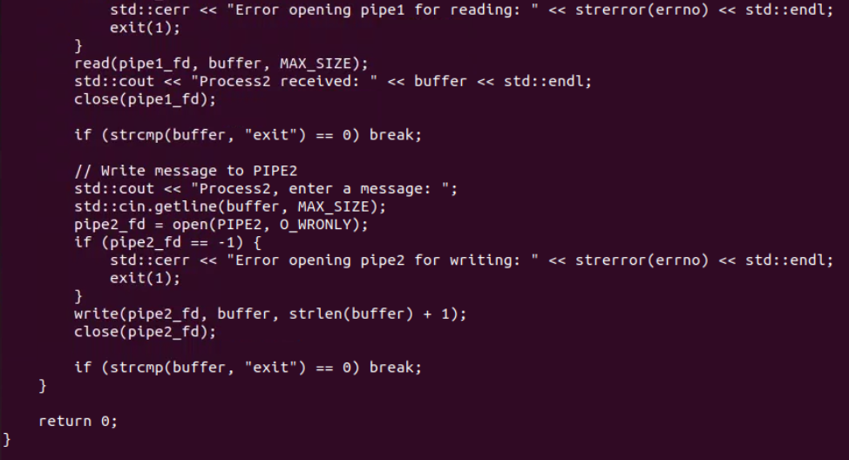

**Fork and Child Process:**

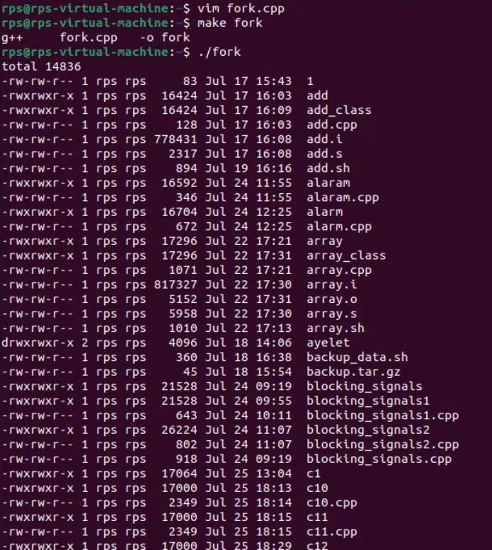

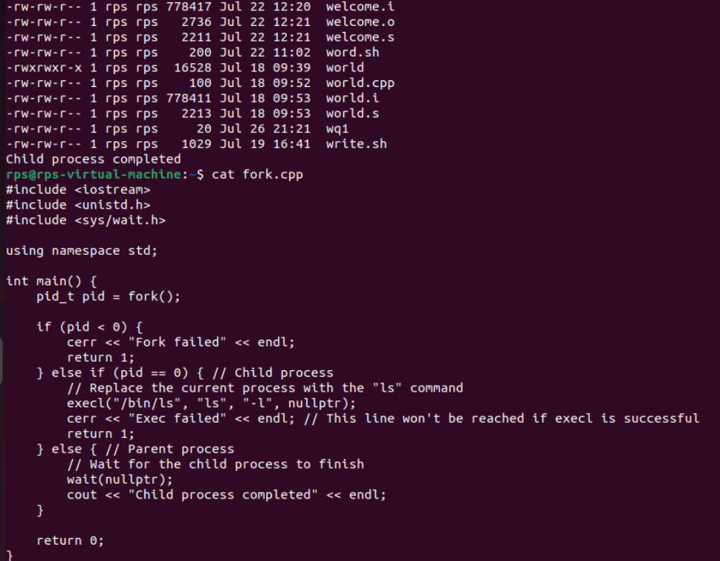

**execvp function:**

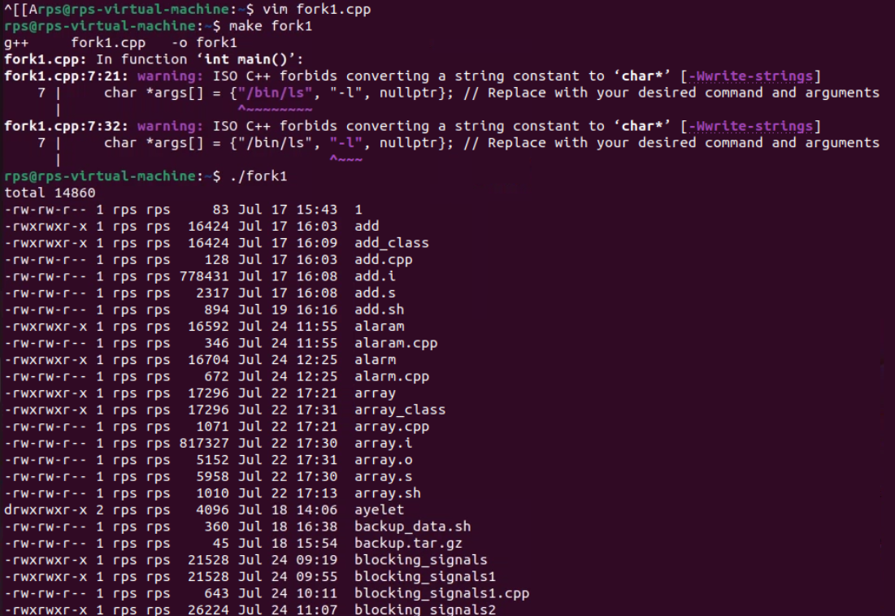

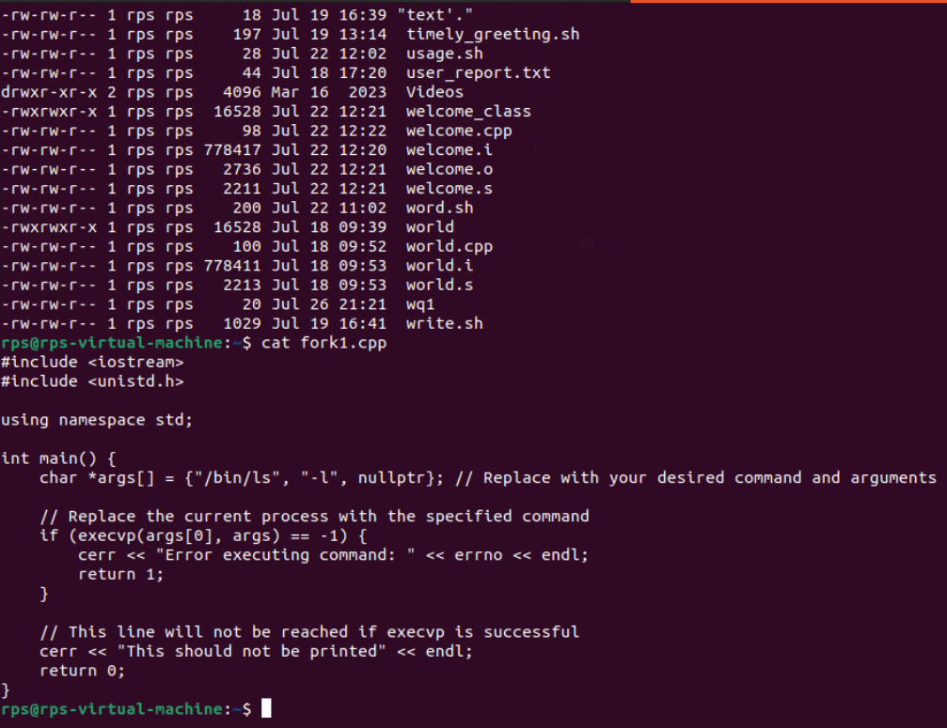

**child using fork while using execvp function**

